Data Assessment Template
This document should be completed by the project group for the 2nd assessment.

Group | Student 1 | Student 2 | Student 3 | Student 4

Assessment Cycle
Table 1. Project Group Composition

The Data Assessment takes place prior to the instantiation of the AI System.
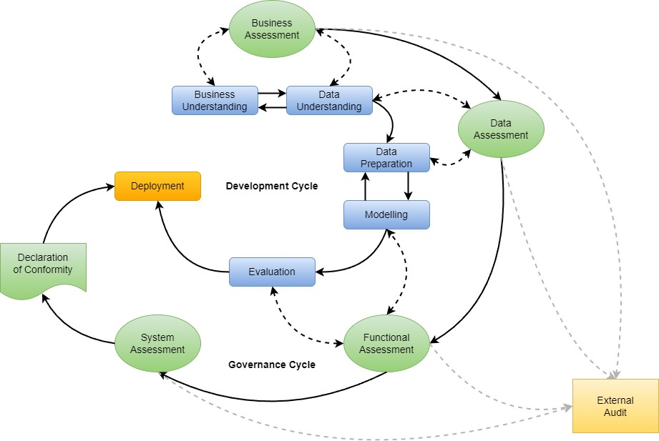
Figure 1. Development & Governance Cycles with External Audit

Additional Instructions
In certain sections, you are asked to select one variable (or sometimes two variables) in order to carry out a particular task. Always select variables which have no missing values.
To test this, in R use:
> sum(is.na(file_name$variable_name))
To test this in Python use the following pandas function on your dataframe:
> .isnull() or > .isna()

Data Assessment
The Data Assessment is comprised of the following four segments:
- Data Composition
- Data Exploration
- Data Investigation
- Information Engineering
Each of these segments is set out in the sections below.

Data Composition
This segment is comprised of the following three elements:
  - Dataset Classification
  - Variable Classification
  - Dataset Quantification

Dataset Classification
Classify the dataset in terms of its format, arrangement, and representation of missing values.

Data Format
Select the appropriate format type for the dataset.

# | Description | Structured | Unstructured | Semi-structured
1 | What is the format of the dataset?

Data Arrangement
Table 2. Data Format

Select the appropriate arrangement type for the dataset.

# | Description | Vector | List | Matrix | Data Frame
1 | What is the arrangement of the dataset?

Missing Values
Table 3. Data Arrangement

Select the appropriate representation of missing values. (If there are no missing values, select None).

# | Description | NULL | NA | Blank | (None)
1 | How are missing values represented in the dataset?
Table 4. Missing Values

Variable Classification
Classify each variable in terms of its symbol type and generic data type.

Symbol Types
For each variable, select the appropriate symbol type.

# | Variable | Alphabetic | Numeric | Alphanumeric
1
2
...

Generic Data Types
Table 5. Symbol Types

For each variable, select the appropriate generic data type.

# | Variable | Nominal | Ordinal | Discrete | Continuous | Boolean | Date
1
2
...

Dataset Quantification
Table 6. Generic Data Types

Was the data sourced using random or multiple sampling?
# | Data Sampling Method | Yes | No
1 | The data was sourced using random sampling
2 | The data was sourced using multiple sampling
Table 3. Data Sourcing

Quantify the dataset in terms of cells, missing values, variables, observations, and duplicates.

# | Description | Count
1 | What is the total number of cells in the dataset?
2 | What is the total number of missing values?
3 | What is the total number of variables in the dataset?
4 | What is the total number of observations in the dataset?
5 | What is the total number of duplicates in the dataset?

Table 7. Dataset Quantification

Data Exploration
This segment is comprised of the following five elements:
  - Data Diversity
  - Central Tendency
  - Data Shape
  - Data Volatility
  - Data Outliers

Data Diversity
For each variable, record the number of unique values, the least frequent value, most frequent value.

# | Variable | # Unique Values | Least Frequent | Most Frequent
1
2
...
Table 8. Uniqueness & Frequency
For each numeric variable, record the minimum and maximum values.
.

# | Variable | Min. Value | Max. Value
1
2
...

Central Tendency
Table 9. Value Range

For each numeric variable, record the median and mean value.

# | Variable | Median | Mean
1
2
...

Table 10. Central Tendency

Data Shape

Select one numeric variable, plot its distribution (graph), and assess its modality and dispersion.

Variable:
# | Measure |  | Description |  | Value
 | Modality |  | Is the data distribution of the variable unimodal? (Yes/No)
 | Modality |  | What is the location of the data? (uniform, symmetrical, right-skewed, left-skewed)
 | Dispersion |  | What is the dispersion of the variable's values? (relatively Steep, relatively Flat)

Graph
Table 11. Data Shape

[insert graphs here]
Figure 2. Data Distribution

Data Volatility
Select one numeric variable, and record its spread, concentration, and deviation.

Variable:
# | Measure |  | Description |  | Value
1 | Spread I |  | What is the variable's value at the 1st quartile?
2 | Spread II |  | What is the variable's value at the 2nd quartile?
3 | Spread III |  | What is the variable's value at the 3rd quartile?
4 | Spread IV |  | What is the variable's value at the 4th quartile?
5 | Concentration |  | What is the variable's Inter-Quartile Range (IQR)?
6 | Deviation |  | What is the standard deviation for the variable?

Data Outliers
Table 12. Data Volatility

Select one numeric variable, generate a box plot (graph), and record whether there are any outliers.

# | Variable | Outliers (Y/N)
1

Graph
Table 13. Outliers

NB The code for generating a box plot was not covered in the lecture series.
Use can use the syntax for R below:
> boxplot(file_name$variable_name)
Or use python pandas library on your dataframe:
> .boxplot(column=["Col1", "Col2", "Col3"])
where “Col1” etc. should be replaced with your column of choice:
Save the graph and insert it below.
[insert graph here]
Figure 3. Box Plot

Data Investigation
This segment is comprised of the following two elements:
- Data Covariation
- Data Correlation

Data Covariation
Investigate whether variables interact with each other. Select two numeric variables and plot their covariance. Record the monotonicity and linearity of their relationship.

Graph

[insert graph here]
Figure 4. Data Covariation

Variable #1: |  |  | Variable #2:
# | Measure |  | Monotonic | Modulated | Linear | Non-Linear
1 | Monotonicity
2 | Linearity

Data Correlation
Table 14. Data Covariation

Record the correlation of each numeric feature with the target variable, in terms of direction and strength. (In the case of Unsupervised Learning, select any numeric variable in place of the target).

# | Feature | Pos/Neg | Strength
1
2
...
Table 15. Data Correlation

Information Engineering
This segment is comprised of the following elements:
- Data Description
- Personalisation
- Conceptualisation
- Data Association
- Data Availability & Causal Factors
- Data Selection
- Data Preparation
- Quantification of Success

Data Description
For each variable in the dataset, record a short description of its business semantics (meaning).

# | Variable | Description
1
2
...
Table 16. Data Description

Personalisation
For each variable in the dataset, record whether it constitutes personal data or not. If it does constitute personal data, record whether it is also a protected category or not.

# | Variable | Personal Data (Y/N) | Protected Category (Y/N)
1
2
...

Data Delimitation
Table 17. Personalisation

For each variable in the dataset, record whether the values it could take are restricted (delimited) in any way. If they are, record whether this is (a) via a Min and/or Max, or (b) via a List of permitted values.

# | Variable | Non-Delimited | Has Min | Has Max | Has List
1
2
...

Conceptualisation
Table 18. Data Delimitation

Each of the variables in the dataset refers to a real-world business entity (referent).

Table
For each variable in the dataset, record the entity to which you think it refers, together with whether the variable represents a Physical or Informational property, and whether the variable is Continuant (continued process) or Occurrent (event based).

# | Variable | Entity | Physical | Informational | Continuant | Occurrent
1
2
...

Table 20. Conceptualisation

Example
The table below shows an example of identifying the business entities to which the variables refer, together with entity categorisation in terms of being Physical or Informational, and Continuant or Occurrent.

# | Variable | Entity | Physical | Informational | Continuant | Occurrent
1 | homeownership | Borrower | Y |  | Y
2 | loan_purpose | Application |  | Y |  | Y
3 | installment | Loan |  | Y |  | Y
4 | interest_rate | Loan |  | Y |  | Y
5 | sub_grade | Loan |  | Y |  | Y
6 | total_debt_to_income | Credit Profile |  | Y | Y
7 | income_verification | Credit Profile |  | Y | Y
8 | delinq_2y | Credit History |  | Y | Y
9 | loan_status | Loan |  | Y |  | Y
Table 19. Conceptualisation Example

Data Association
The recorded business entities (referents) are generally also related to one another.

Example
The diagram below shows an example of a simple entity relationship diagram (ERD).
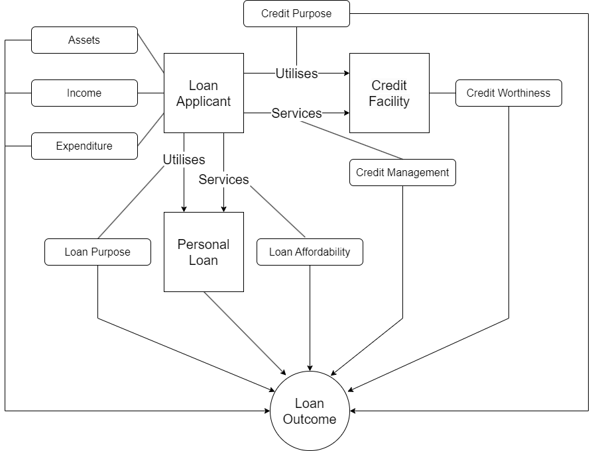

Figure 7.
Figure 7. Example ERD

Diagram

What is the causal model (entities, actions, causal factors) for the system? For the identified business entities, generate an entity relationship diagram to visualize how data is being obtained and processed. Use arrows to indicate directionality between actions or entities (one-way, two ways). Insert the ERD below. (Use your preferred drawing software, e.g., draw.io).
[insert ERD]
Figure 8. Entity Relationship Diagram

Data Availability & Causal Factors
What are the causal factors associated with each business entity? Which of the specified causal factors are available within the data sample? You may use your ERD to complete the table below. For each causal factor, indicate whether it is available. It is possible that aspects that you’ve identified as fundamental in your ERD, are not available in the dataset you’ve received. In that case, list the availability as “No”
Example
# | Business Entity | Causal Factor | Yes | No
1 | Loan Applicant | Assets | X
2 | Loan Applicant | Income | X
3 | Loan Applicant | Expenditure |  | X
4 | Credit Facility | Credit Purpose |  | X
5 | Credit Facility | Credit Worthiness | X
6 | Credit Facility | Credit Management | X
7 | Personal Loan | Loan Purpose | X
8 | Personal Loan | Loan Affordability | X
Table 2. Data Availability
Data Availability is 6 / 8 = 75 %.

Data Selection

Target Variable
Which variable within the data sample was selected as the target variable? Or can a target be made from an existing variable? (Think back to your business understanding, what should be predicted or how can a classification solve the business objective?)
The expected selected target variable is

Redundant Features
Which variables within the data sample were considered redundant and why?
The following variables are fundamental but unknown:

The following variables are considered irrelevant for determining the outcome:

The following variables are unusable due to their formulation and/or data integrity: (provide reasoning why variables are unusable)

Causal Features
Which variables within the data sample were selected as representative of causal factors? Explain how they contribute to predicting the target.

Data Preparation
Data Preparation is comprised of the following three sub-elements:
- Variable Adjustment
- New Variables
- Variable Encoding

Variable Adjustment
Which variables within the data sample need to be or were adjusted in order to facilitate data analysis?

New Variables
Which new variables could be created from the existing variables in order to facilitate further data analysis?

Variable Encoding
Which variables within the data sample could be or were encoded in order to facilitate data analysis? Take into account nominal and ordinal encoding as well as possible encoding of categories into numeric binary.

Final Variable Set
What is the final variable set (with causal factor and correlation) for the model?
# | Causal Factor | Variable | Correlation | Target
Table 27. Final Variable Set

Data Cleaning
For the Final Variable Set, what further data cleaning was required? (Think about adjusting typo’s, measurement errors, mitigating outliers)

Quantification of Success
What are the data mining goals and associated performance metrics for the project?
Data Mining Goal

The primary data mining goal is to develop…

Choose the appropriate metrics for your use case: regression may include MAE, RSME, MSE while classification includes: Accuracy, Recall, Specificity, Sensitivity, F1 score.
Performance will be measured by …. which is crucial for our business objective because if focuses on….

Performance Metrics

1. Estimated Accuracy in population will be measured by ….

2. Relative Accuracy to current system will be measured by …..

3. Overall Confidence in model performance will be measured by ….

